**Progress Report – Sean Estrebillo**

**Week 8**

**Tail Stock inventor drawing**

To have been able to start a tailstock inventor drawing, dimensions were taken from the actual tailstock of the lathe machine that is provided for our group. After acquiring the necessary dimensions of the tailstock I was able to start the inventor drawing and was able to create the body part of the tail stock, but the drawing is far from finishing there are still more parts of the tailstock that needs to be drawn in inventor such as lever locks and wheel for adjusting the centring tool.

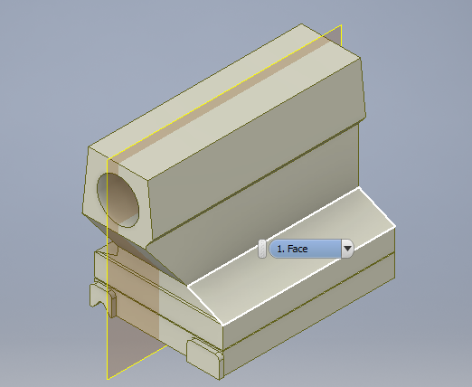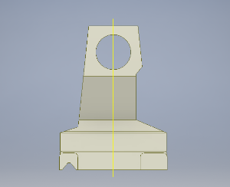

Front View

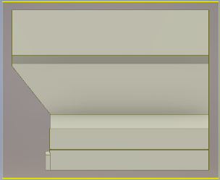

Right Side View

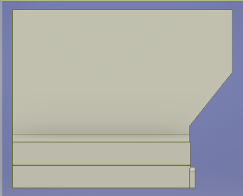

Home View

Left Side View

**Research**

**Properties of Mild Steel**

[**http://mechanicalinventions.blogspot.com.au/2014/08/mild-steel-properties-of-mild-steel.htm**](http://mechanicalinventions.blogspot.com.au/2014/08/mild-steel-properties-of-mild-steel.htm)

I’ve done some research on the properties of mild steel and found out its characteristics such as being tough, ductile and malleable, it also has good tensile strength but poor corrosion resistance. It is mainly used as an all-purpose engineering material. These information are necessary to be able to know more about this material and identify the necessary force that we need to apply to be able to cut this metal into our CNC lathe.

Lathe tool bit

Also searched about different kinds of tool bit such as chamfering tool and Grooving & Cut-off Tool. Even though we seem to have enough tool bit that are in a good condition, it is still good to have extra information about it and where we can get it.

Kinds of Lathe tool bit

<http://littlemachineshop.com/products/product_focus.php?Focus=Cutting%20Tools%20Lathe>

Chamfering tool, ½” Indexable, SCSCR-08-3A, Tormach

* 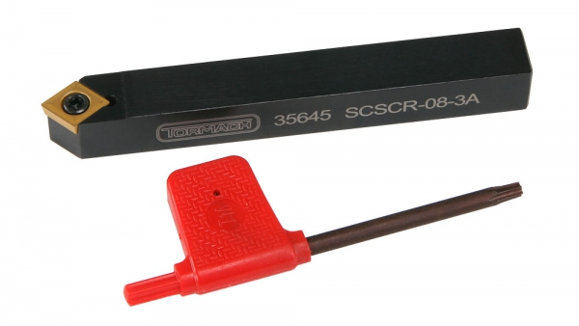 Designation: SCSCR-08-3A
* Steel shank ½” x 4”
* Designed for CCMT and CCGT 32.51 inserts
* Approach 45® , 7® relief angle
* Insert Shape: 80® (C)
* Price, $39.83

Grooving & Cut-off Tool, ½” indexable HHS Inserts, A R Warner

* 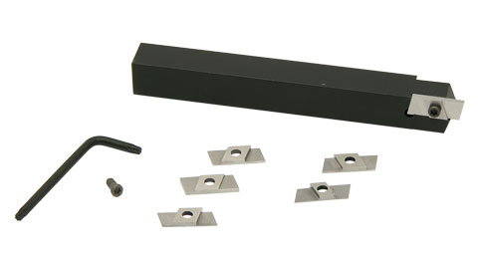For external grooving and cut-off operations
* Includes two 1/16” (.062”) groover T-15 high speed steel inserts
* Includes two 1/32” (.031”) groover T-15 high speed steel inserts
* Includes two 1/64” (.016”) groover T-15 high speed steel inserts
* Includes two IS 3007 screws and one T-9 wrench
* Price, $135.00

Colchester-Student-1800 Basic Operation

<http://www.powershow.com/view4/6efb60-MDUxO/Colchester_Student_1800_Basic_Operation_Manual_powerpoint_ppt_presentation>

I found some good information online on how to use the lathe step by step. It is necessary for us to know the basic operation of the kind of lathe that we are converting into a CNC machine, because it will give us ideas on how to make the controls better and the purpose of the parts that we are still using.